OS Schedule Lab Report:

In this part, I implemented long-term scheduling. I created a list of processes using the values from Table 1 and then used a C# function to filter jobs based on priority. In my solution, only processes with a priority greater than 5 were admitted into the system. This simulates how a long-term scheduler decides which jobs are allowed into the ready queue before CPU scheduling begins. This helped me understand how operating systems control workload before execution.
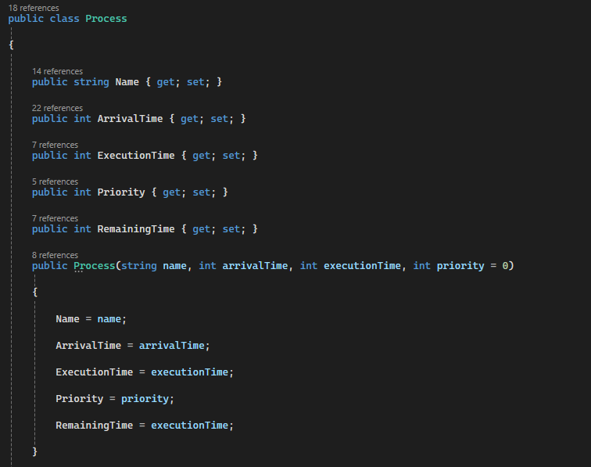
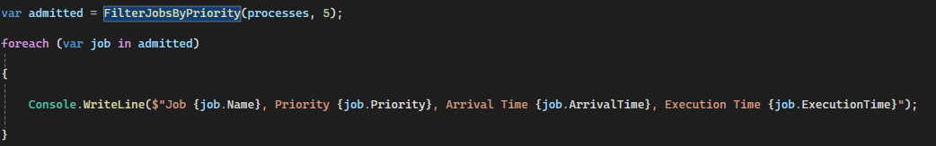
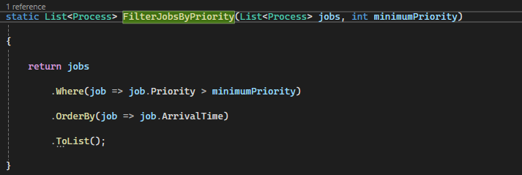

Here I used FCFS scheduling, which executes processes in arrival order. The program calculates the required scheduling metrics and prints a Gantt chart to show the order of execution. This demonstrates how FCFS is easy to understand but can lead to long waiting times for processes that arrive later.
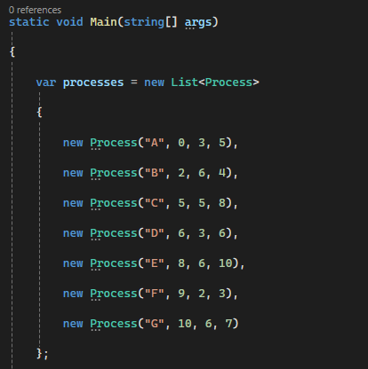
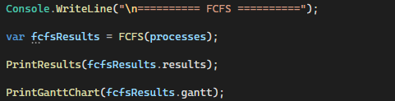
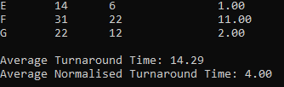

In this part, I implemented Round Robin scheduling using different time slices: 1, 3, 4 and 6. Unlike FCFS, Round Robin gives each process a fixed amount of CPU time before moving it to the back of the queue if it has not finished. My program calculates the same metrics as FCFS and produces a Gantt chart for each time quantum. By comparing the results, I could see how the size of the time slice changes the behaviour of the schedule. Smaller time slices improve fairness, while larger time slices make the algorithm behave more like FCFS.
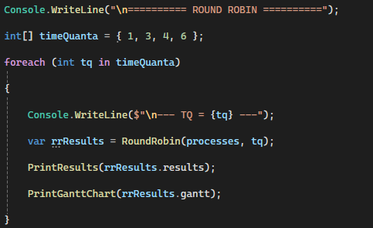
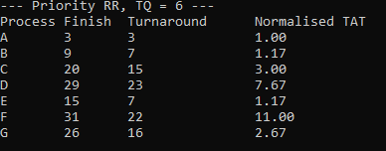

In this extension, I modified the Round Robin simulation to include priority-based scheduling using the original process table. The scheduler first considers priority and then applies Round Robin with different time slices. I tested this with time quanta of 1 and 6 and plotted Gantt charts for both. This allowed me to observe how priority affects which process gets CPU time first, while the time quantum still controls how often context switching happens. This demonstrates how a scheduler can balance fairness and importance when multiple processes are competing for CPU time.
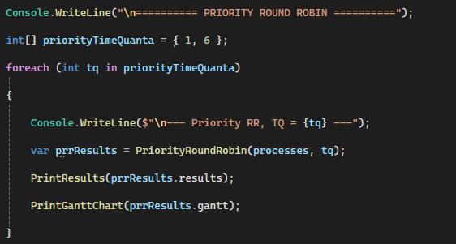
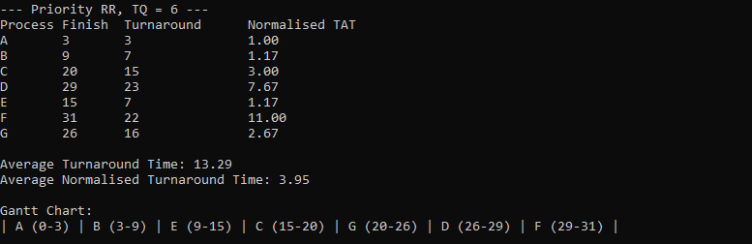

Overall, this lab helped me understand the difference between long-term scheduling and CPU scheduling. I implemented FCFS and Round Robin in C#, calculated scheduling metrics, and used Gantt charts to visualise process execution. I also extended the simulation with priority-based scheduling to see how importance and time slicing affect performance. This gave me practical experience of how operating systems manage processes and CPU time.

